(Appendix 2)

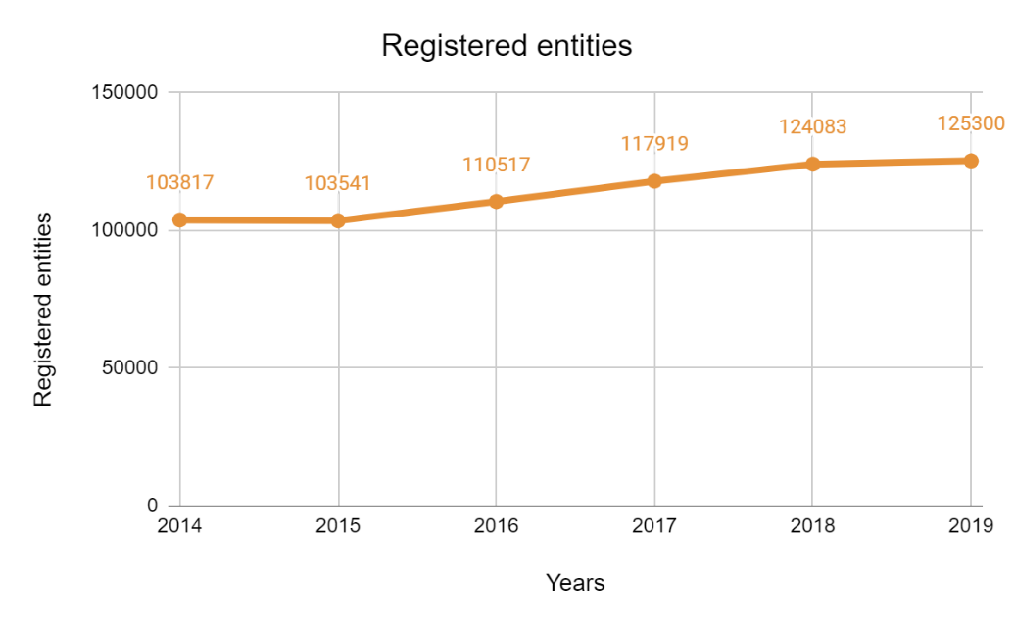
FIGURE 2. Official registered entities
Source: Compiled by the author based on the data from the Bureau of National Statistics (2022)

